DAY 3

Pizza Order Practice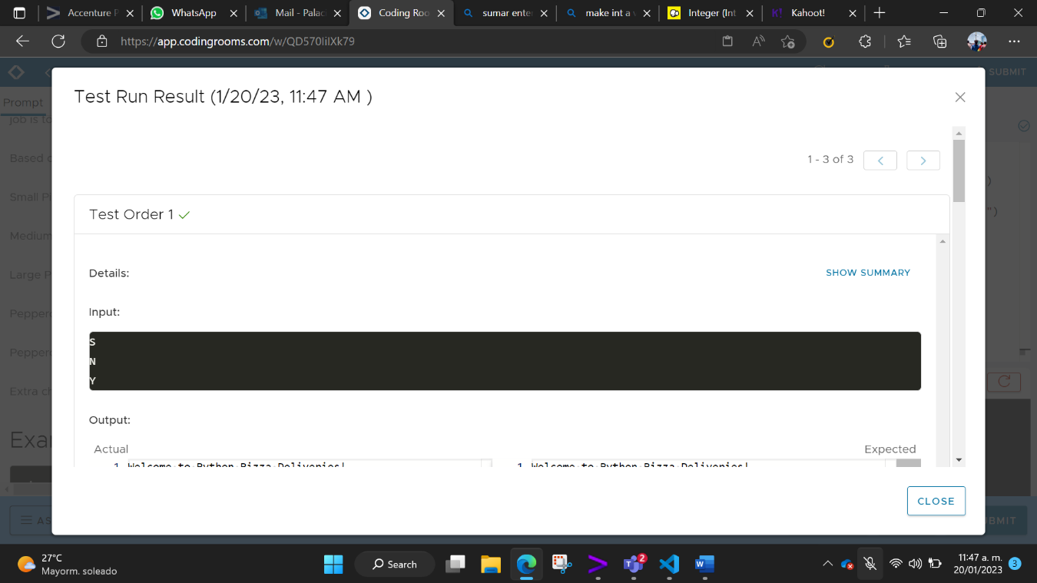

Rollercoaster

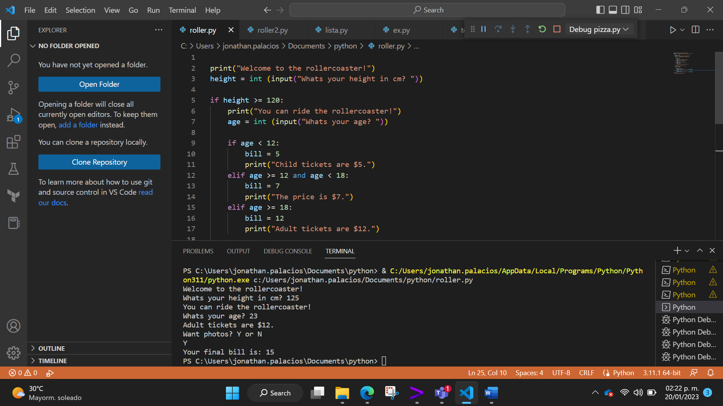

Rollercoaster 2

Name List

Name List 2

